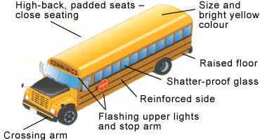

Parents - what makes a school bus safe
British Columbia and SD No.23 regulations require buses be driven by specially-trained drivers with good driving records. Additionally, SD No. 23 school bus drivers are required to have Class 2 with airbrake certification and pass a Medical exam annually. School buses must meet safety standards established by Transport Canada (D-250 Standards), including the recent addition of a requirement for a front safety crossing arm. Other standards include:

Why no seat belts?
Information from all types of school bus collisions demonstrates that the current school bus design provides a high level of protection to occupants and that seatbelts may actually adversely affect the safety of children on school buses (Transport Canada).
Instead of requiring seat belts, school buses are designed and constructed differently from passenger cars. School buses protect passengers through "compartmentalization", a design that includes:
- Seats with high backs;
- Seats filled with energy-absorbing material;
- Seats placed close together to form compartments;
- Strong seat anchorages.
Studies have shown that adding seat belts to the current seating configuration of a school bus can increase the chance of head and neck injuries. For a seat belt to be effective, it must be worn correctly, snug and on the upper thighs. Because school vehicles carry passengers from the very young to high school students, if seat belts were used, they would need to be readjusted and their use monitored. A seat belt not worn correctly may cause serious injuries.

